**Command Line Interface challenge**

Before you start any of the exercises, make sure to create a folder on your desktop that will hold all of your exercise files. Give the folder the name hyf-html-exercises. Inside, create a week1 folder and will hold this week's exercise files inside.

Using the CLI, create a plain text file (.txt) that contains the commands necessary to answer the following questions:

1. How do I create a hidden file or folder? How do I display it in the CLI?
2. How do I create multiple nested directories, like /c/Users/myusername/these/folders/are/just/for/fun?
3. How do I append a message to a file, without a newline character, so the output would be:



# **Answers:**

**1.1-Creating a hidden folder**

Sezgin@DESKTOP-F8VRO1C MINGW64 ~/Desktop/HackYourFuture/Visual Studio Codes (master)

$ mkdir will_be_hidden_folder

Sezgin@DESKTOP-F8VRO1C MINGW64 ~/Desktop/HackYourFuture/Visual Studio Codes (master)

Sezgin@DESKTOP-F8VRO1C MINGW64 ~/Desktop/HackYourFuture/Visual Studio Codes (master)

$ attrib +h will_be_hidden_folder

$ ls

CreatingBird/ Notes/ will_be_hidden_folder/

**1.2-Creating a hidden file**

Sezgin@DESKTOP-F8VRO1C MINGW64 ~/Desktop/HackYourFuture/Visual Studio Codes (master)

$ touch willbehiddentext.txt

Sezgin@DESKTOP-F8VRO1C MINGW64 ~/Desktop/HackYourFuture/Visual Studio Codes (master)

$ attrib +h willbehiddentext.txt

**1.3- Converting hidden files to visible**

Sezgin@DESKTOP-F8VRO1C MINGW64 ~/Desktop/HackYourFuture/Visual Studio Codes (master)

$ attrib -h will_be_hidden_folder

Sezgin@DESKTOP-F8VRO1C MINGW64 ~/Desktop/HackYourFuture/Visual Studio Codes (master)

$ attrib -h willbehiddentext.txt

**2. Creating nested folders**

Sezgin@DESKTOP-F8VRO1C MINGW64 ~/Desktop/HackYourFuture/Visual Studio Codes (master)

$ mkdir -p folder1/folder2/folder3

Sezgin@DESKTOP-F8VRO1C MINGW64 ~/Desktop/HackYourFuture/Visual Studio Codes (master)

$ ls

CreatingBird/ folder1/ will_be_hidden_folder/ willbehiddentext.txt

Sezgin@DESKTOP-F8VRO1C MINGW64 ~/Desktop/HackYourFuture/Visual Studio Codes (master)

$ cd folder1

Sezgin@DESKTOP-F8VRO1C MINGW64 ~/Desktop/HackYourFuture/Visual Studio Codes/folder1 (master)

$ ls

folder2/

Sezgin@DESKTOP-F8VRO1C MINGW64 ~/Desktop/HackYourFuture/Visual Studio Codes/folder1 (master)

$ cd folder2

Sezgin@DESKTOP-F8VRO1C MINGW64 ~/Desktop/HackYourFuture/Visual Studio Codes/folder1/folder2 (master)

$ ls

folder3/

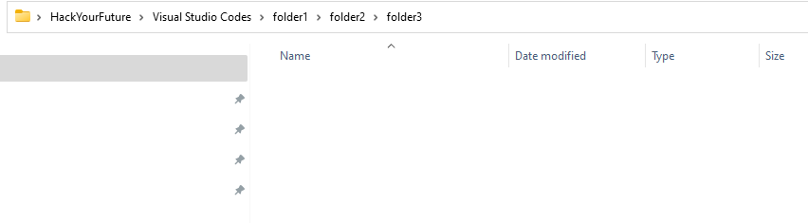

**3-Appending a message to a text file**

Sezgin@DESKTOP-F8VRO1C MINGW64 ~/Desktop/HackYourFuture/Visual Studio Codes (master)

$ { echo ' First Message from HYF'

echo ' Second Message from HYF'

} >> message.txt

Sezgin@DESKTOP-F8VRO1C MINGW64 ~/Desktop/HackYourFuture/Visual Studio Codes (master)

$ cat message.txt

First Message from HYF

Second Message from HYF

Sezgin@DESKTOP-F8VRO1C MINGW64 ~/Desktop/HackYourFuture/Visual Studio Codes (master)